New drug 'halts disease progression' in patients with hard-to-treat Hodgkin lymphoma

Last updated: Friday 20 March 2015 at 12am PST

A new drug has seen success in halting disease progression in adults with hard-to-treat Hodgkin lymphoma following stem cell transplantation, according to the results of a phase 3 trial.

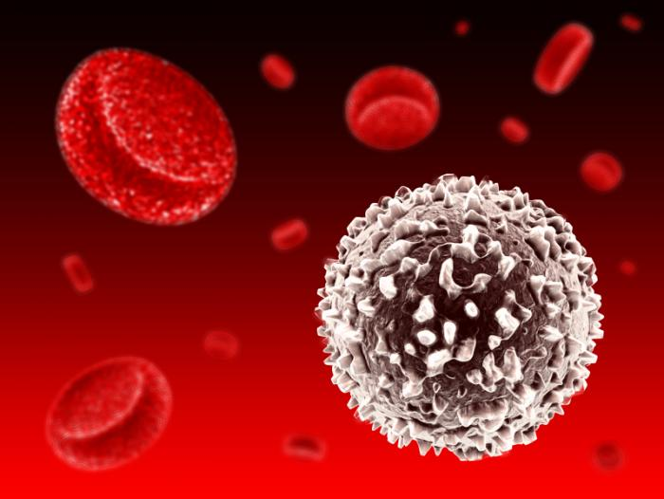

Hodgkin lymphoma, is a cancer of the white blood cells, called lymphocytes. This year, more than 9,000 Americans will be diagnosed with the disease.
Lead study author Dr. Craig Moskowitz, a professor of medicine at Memorial Sloan Kettering Cancer Center in New York, NY, and his team publish their findings in The Lancet.
Hodgkin lymphoma, also referred to as Hodgkin disease, is a cancer of the white blood cells, called lymphocytes. It is the most common type of blood cancer found among individuals aged 15-35, and around 9,050 Americans are expected to be diagnosed with the disease this year.
The two primary treatments for Hodgkin lymphoma arechemotherapy and radiotherapy. While the majority of patients respond to such treatment, others do not, or the cancer comes back within a few months.
For these hard-to-treat patients, high-dose chemotherapy combined with autologous stem celltransplantation (ASCT) becomes an option. ASCT involves replacing the stem cells lost from the high-dose chemotherapy with stems cells from a healthy donor.
However, even after undergoing high-dose chemotherapy and ASCT, around half of patients with hard-to-treat Hodgkin lymphoma do not respond to the treatment or relapse.
For their phase 3 trial, Dr. Moskowitz and colleagues set out to see whether a drug called brentuximab vedotin (BV) - if given to patients immediately after ASCT - could prevent Hodgkin lymphoma progression.
BV is an antibody that sticks to a protein called CD30, which is found on the surface of Hodgkin lymphoma cells. By sticking to this protein, BV has the ability to deliver a strong chemotherapy drug directly to the cancer cells, killing them.

65% of patients treated with BV had no disease progression 2 years after ASCT
The researchers enrolled 329 patients aged 18 or older with Hodgkin lymphoma who were at high risk of disease progression or relapse following ASCT.
After undergoing ASCT, patients were randomly assigned to receive either 16 cycles of BV intravenous infusions once every 3 weeks or a placebo.
The team found that at 2 years after treatment, 65% of patients who received BV had no cancer progression, compared with 45% of patients who received the placebo. On average, BV-treated patients survived for 43 months without disease progression, compared with only 24 months for those who received the placebo.
Since it is unlikely patients will relapse 2 years after ASCT, Dr. Moskowitz says almost all patients who experienced no disease progression during follow-up are likely to be cured.
Some patients treated with BV did experience side effects, the most common of which were numbness due to peripheral nerve damage and low white blood cell count. The team says, however, that the drug was generally well tolerated.
Commenting on the results, Dr. Moskowitz says:
"The bottom line is that BV is a very effective drug in poor-risk Hodgkin lymphoma and it spares patients from the harmful effects of further traditional chemotherapy by breaking down inside the cell resulting in less toxicity.
No medication available today has had such dramatic results in patients with hard-to-treat Hodgkin lymphoma."
In an editorial linked to the study, Prof. Andreas Engert, of the University Hospital of Cologne in Germany, says the trial establishes a "promising new treatment approach" for patients with Hodgkin lymphoma who are at high risk of disease progression.
He notes, however, that an almost 50% survival at 24 months for patients in the placebo group raises the question as to whether many of the patients included were actually at high risk of relapse.
"An international consortium is currently reassessing the effect of risk factors in patients with relapsed Hodgkin lymphoma to define a high-risk patient population in need of consolidation treatment," he adds. "We look forward to a better definition of patients with relapsed Hodgkin lymphoma who should receive consolidation treatment with brentuximab vedotin."
In December 2014, Medical News Today reported on another study by Dr. Moskowitz and colleagues, in which the team found two PD-1 inhibitors - that block the PD-1 protein found on the surface of Hodgkin lymphoma cells - could boost immune system activity of patients with the disease, helping them fight the cancer.
Written by Honor Whiteman

